**ROHS CERTIFICATION**

Distributed by: JBM CAMPLLONG, S.L.U.

Address: CIM La Selva – Crta. Aeroport Km 1.6 Nave 2.2, 17185 Vilobí d’Onyar, Girona

CIF (VAT number): B17419292

Product’s description: USB CABLE A TYPE / ROUND PLUG 3.5MM

Manufacturer’s reference: CB-105

Distributor’s reference: 16052

The declaration object complies with the Directive 2011/65/EU of the European Parliament and of the Council of 8 June 2011 on the restriction of the use of certain hazardous substances in electrical and electronic equipment, and the following standards:

|  |  |  |
| --- | --- | --- |
| **Standard** | **Title** | **Edition/ Date** |
|  |  |  |
| IEC63231-3-1 | Determination of certain substances in electrotechnical products - Part 3-1: Screening - Lead, mercury, cadmium, total chromium and total bromine by X-ray fluorescence spectrometry. | 2013 |
| IEC63231-5 | Determination of certain substances in electrotechnical products - Part 5: Cadmium, lead and chromium in polymers and electronics and cadmium and lead in metals by AAS, AFS, ICP-OES and ICP-MS. | 2013 |
| IEC63231-6 | Determination of certain substances in electrotechnical products - Part 6: Polybrominated biphenyls and polybrominated diphenyl ethers in polymers by gas chromatograhy -mass spectometry (GC-MS). | 2015 |
| IEC63231-7-1 | Determination of certain substances in electrotechnical products - Part 7-1: Hexavalent chromium - Presence of hexavalent chromium (Cr(VI)) in colourless and coloured corrosion-protected coatings on metals by the colorimetric method. | 2015 |
| IEC63231-7-2 | Determination of certain substances in electrotechnical products - Part 7-2: Hexavalent chromium - Determination of hexavalent chromium (Cr(VI)) in polymers and electronics by the colorimetric method. | 2017 |
| IEC63231-4 | Determination of certain substances in electrotechnical products –  Part 4: Mercury in polymers, metals and electronics by CV-AAS, CV-AFS, ICP-OES and ICP-MS. | 2013 |
| IEC63231-8 | Determination of certain substances in electrotechnical products - Part 8: Phthalates in polymers by gas chromatography-mass spectrometry (GC-MS), gas chromatography-mass spectrometry using a pyrolyzer/thermal desorption accessory (Py-TD-GC-MS). | 2017 |

Signed by:

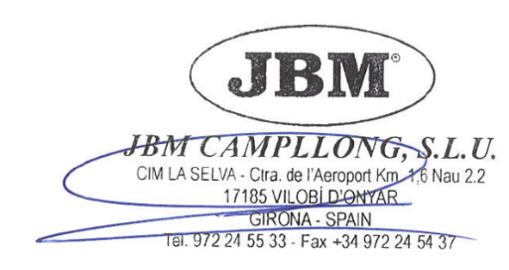

Eduard Godoy

Purchasing department director Girona, 17th August, 2022

